MATHS  Measurement:  - mass (kg/g)  - volume/capacity (l/ml)  - length and perimeter  Time:  - tell and write the time from an analogue clock  - compare durations of events  Shape:  - draw 2-D shapes  - recognise 3-D shapes  - identify right angles  - perpendicular and parallel lines  Money:  - converting pounds and pence |  |  | ENGLISH  Expression week – I am poetry  Balanced argument – Should animals be kept in captivity?  Story writing – desert island  Instructions – how to read maps  Science – healthy lifestyle  Information text – desert biomes  WWF – letter writing |  |  | SCIENCE  Animals including humans  - Animals, including humans, need the right types and amount of nutrition. They get nutrition from what they eat.  - Humans and other animals have skeletons and muscles for support, protection and movement.  Light  - Recognise that we need light in order to see things.  - Notice that light is reflected from surfaces.  - How are shadows formed?
 |  |  | GUIDED READING  Varjak Paw by S.F. Said  A Place Called Perfect by Helena Duggan |  | HISTORY  How did early Baghdad compare to London during the Anglo-Saxon period?  Who is the richest man who ever lived?
PERSONAL DEVELOPMENT  Keeping healthy. Self-worth and self-image.  Problem solving and time management. |  | RE  Do Muslims worship Muhammed?  How do Muslim people worship? |  |  |  | GEOGRAPHY  How do maps work?  What is life like in a desert biome?  How does the weather in the UK change between the seasons?
PE  Netball  Cricket  Athletics | FRENCH  Days of the week  Seasons  Numbers 13-31  Families  What is the date? |  |  | MUSIC  Ukulele – Reggae music.  Baroque period. String instruments.
 |  |  |  | ART/DT  Drawing – self-portraits, every child an artist  Textiles – making a plush toy, cooking |  | 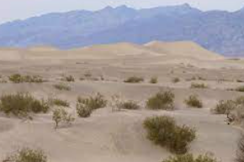  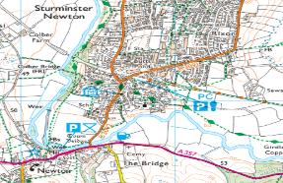
OUR CORE VALUES  Expression  Pride |  |  |  | COMPUTING  Branching Databases  Graphing

