Ancient Egyptians – Home learning project

We would like you to have a go at completing one or two of the activities to help support our learning on the Ancient Egyptians for after half term.
Bring your creations into school or take pictures to present to the class by the 9th December.

Make a pyramid out of card. Sand could be used mixed with paint to give it texture. Make the sarcophagus, coffin and mummy to go inside as well! | Design your own Egyptian God or Goddess.  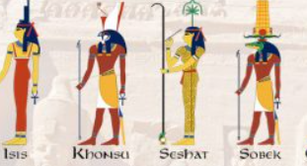 | Make a papyrus scroll and draw on it with hieroglyphics.  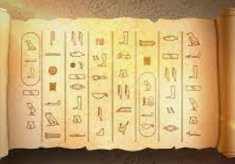
Ancient Egyptians liked gold jewellery, can you design and make your own gold bands and collars? Old plastic water bottles are good for cuffs, cut a ring, cover in foil or paint then add details with beads for jewels or felt tip for patterns. | Ancient Egyptians loved their cats. Can you make yourself a cat mask?  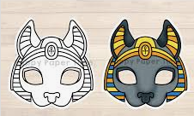 | Draw a map of a pharaoh’s tomb. Write a set of instructions on how to safely get through, avoiding any traps!
Research and find interesting landmarks in Egypt. | Design a leaflet to encourage tourism to the country Egypt. | Imagine you have been on a dig. Write a diary entry about your adventure.
Choose an ancient Egyptian god or goddess and create a fact file, book, or poster all about them. | Write an Ancient Egyptian themed poem or story. | Using the words Ancient Egypt, create an acrostic poem.
Find and make some Ancient Egyptian recipes. | 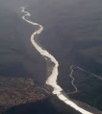  Design a fact file or poster about the River Nile. | Draw or trace a map of Egypt and mark important landmarks.

